REPORT 3

Design And Analysis of Algorithms

Assignment 3

Gaisa Aldiyar

Rakmetollayev Askhat

SE-2416

Analytical Report: Optimization of City Transportation Network (Minimum Spanning Tree)

**Introduction**

This report presents the application and analysis of Prim’s and Kruskal’s algorithms for optimizing a city’s transportation network. The objective is to connect all districts in the city with a minimal total construction cost, modeled as a minimum spanning tree (MST) problem on a weighted undirected graph.

Kruskal's and Prim's algorithms are two classic greedy algorithms used to find a Minimum Spanning Tree (MST) of a weighted, connected, undirected graph. An MST is a subset of edges that connects all vertices together without any cycles and with the minimum possible total edge weight.

**Kruskal's Algorithm**

Kruskal's algorithm works by: Askhat

Sorting all edges of the graph in non-decreasing order by weight.

Starting with an empty spanning tree, the algorithm iteratively adds the next lightest edge to the tree, provided it does not create a cycle.

A disjoint-set (Union-Find) data structure is typically used to efficiently check whether adding an edge will form a cycle.

The algorithm continues until all vertices are connected.

It is well suited for sparse graphs and when edges can be easily sorted.

**Prim's Algorithm**

Prim's algorithm works by: Aldiyar

Starting from an arbitrary vertex and growing the MST one vertex at a time.

At each step, it adds the smallest weighted edge that connects a vertex in the MST to a vertex outside it.

Typically implemented with a priority queue to quickly find the lowest-weight edge.

It continues until all vertices are included in the MST. Prim's algorithm is efficient for dense graphs and when the graph is represented with adjacency structures.

The city administration plans to construct roads connecting all districts in such a way that:

1)each district is reachable from any other district;

2)the total cost of construction is minimized.

This scenario is modeled as a weighted undirected graph, where:

1)vertices represent city districts,

2)edges represent potential roads,

3)the edge weight represents the cost of constructing the road.

**Data Summary and Algorithm Results**

The input consists of five test graphs representing various city district layouts and road connection options. Each graph is specified as JSON files detailing nodes (districts) and weighted edges (potential roads with construction costs).

For each test graph, both Prim’s and Kruskal’s algorithms were implemented and run to find MSTs. Execution times, key operations (comparisons, unions), MST edges, and total costs were recorded.

Prim:

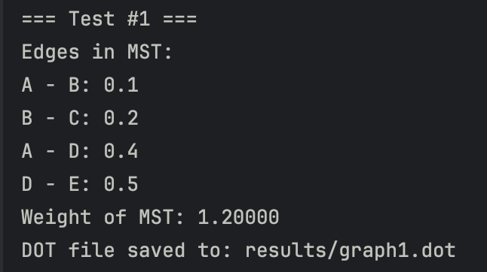

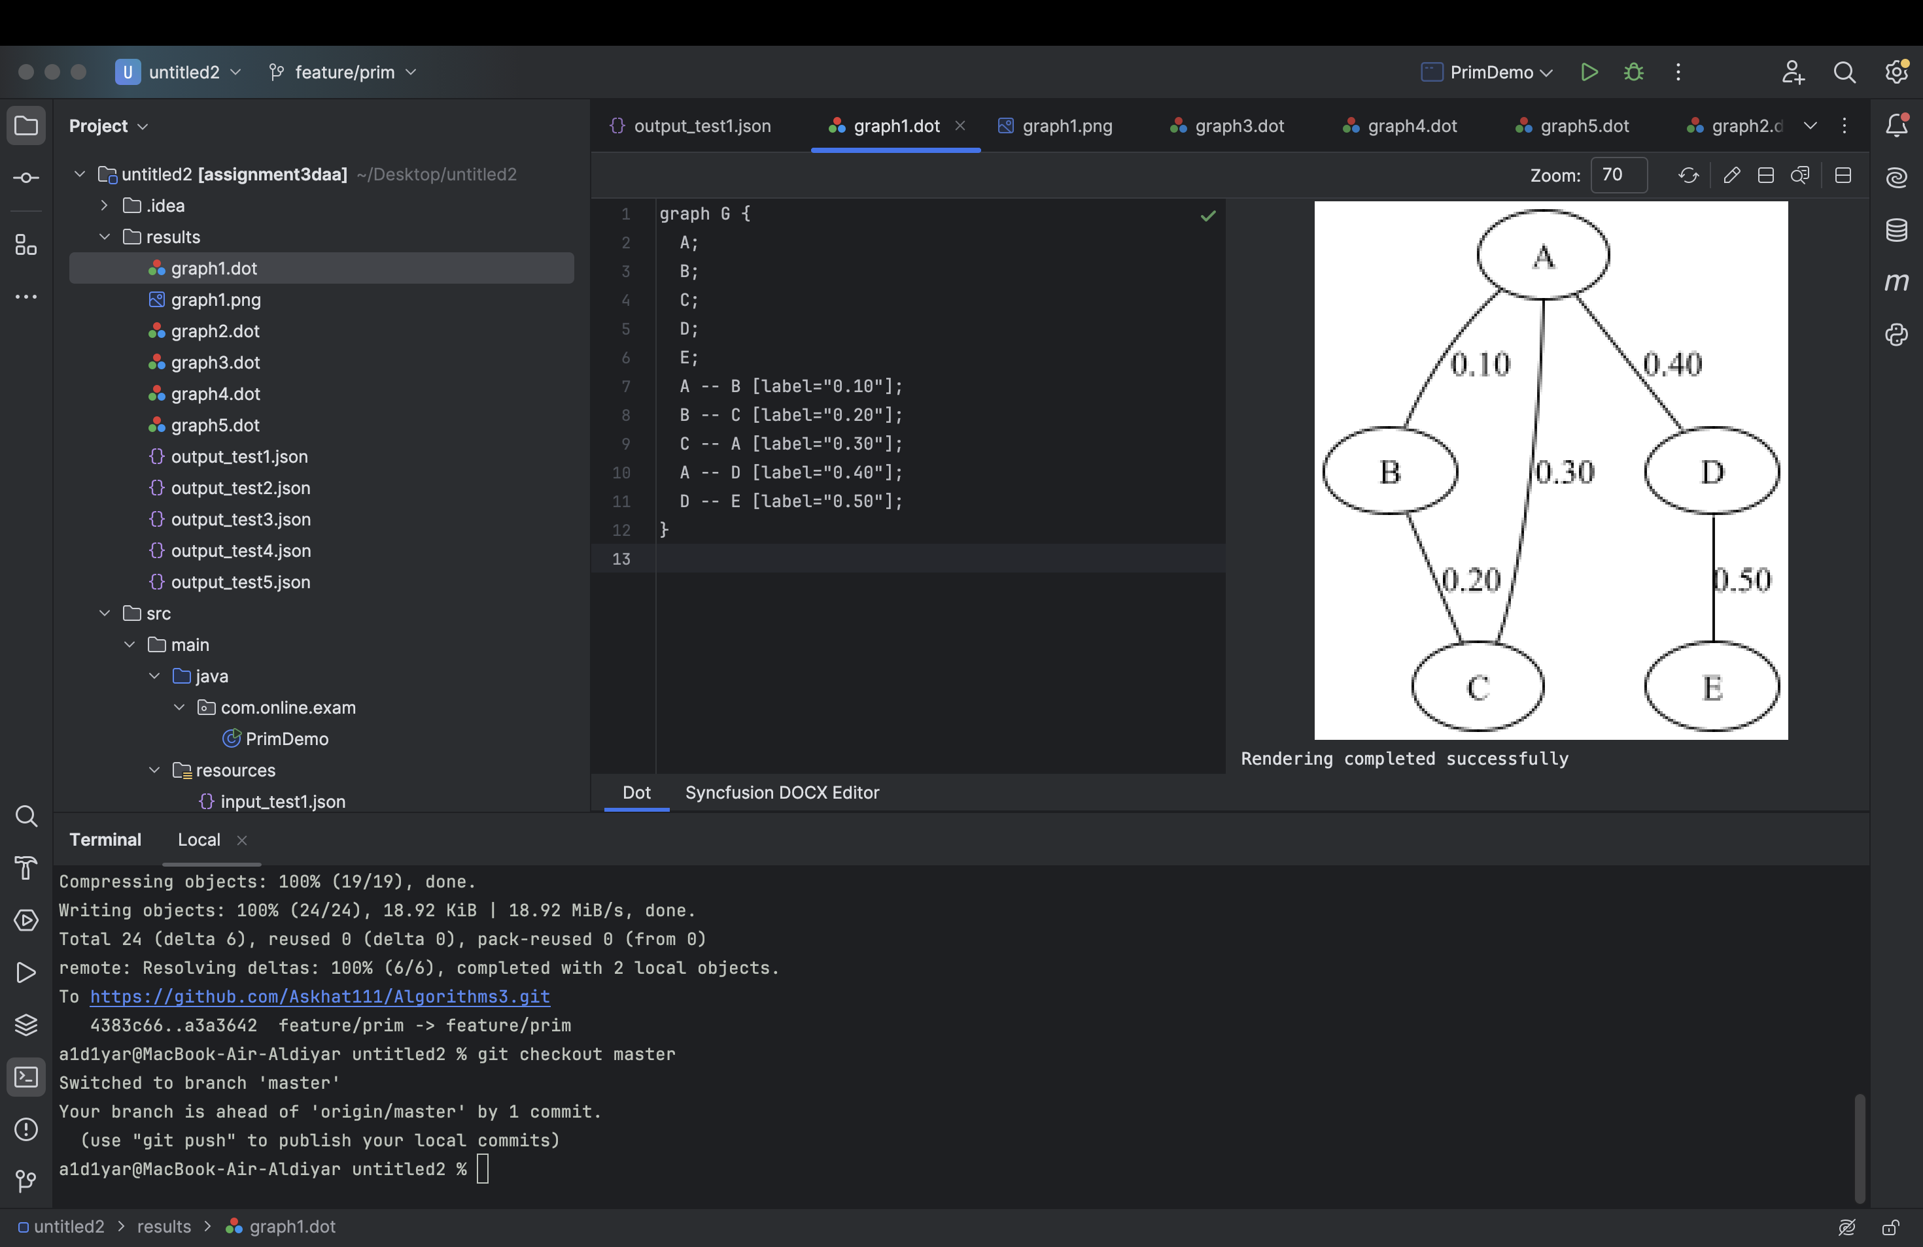

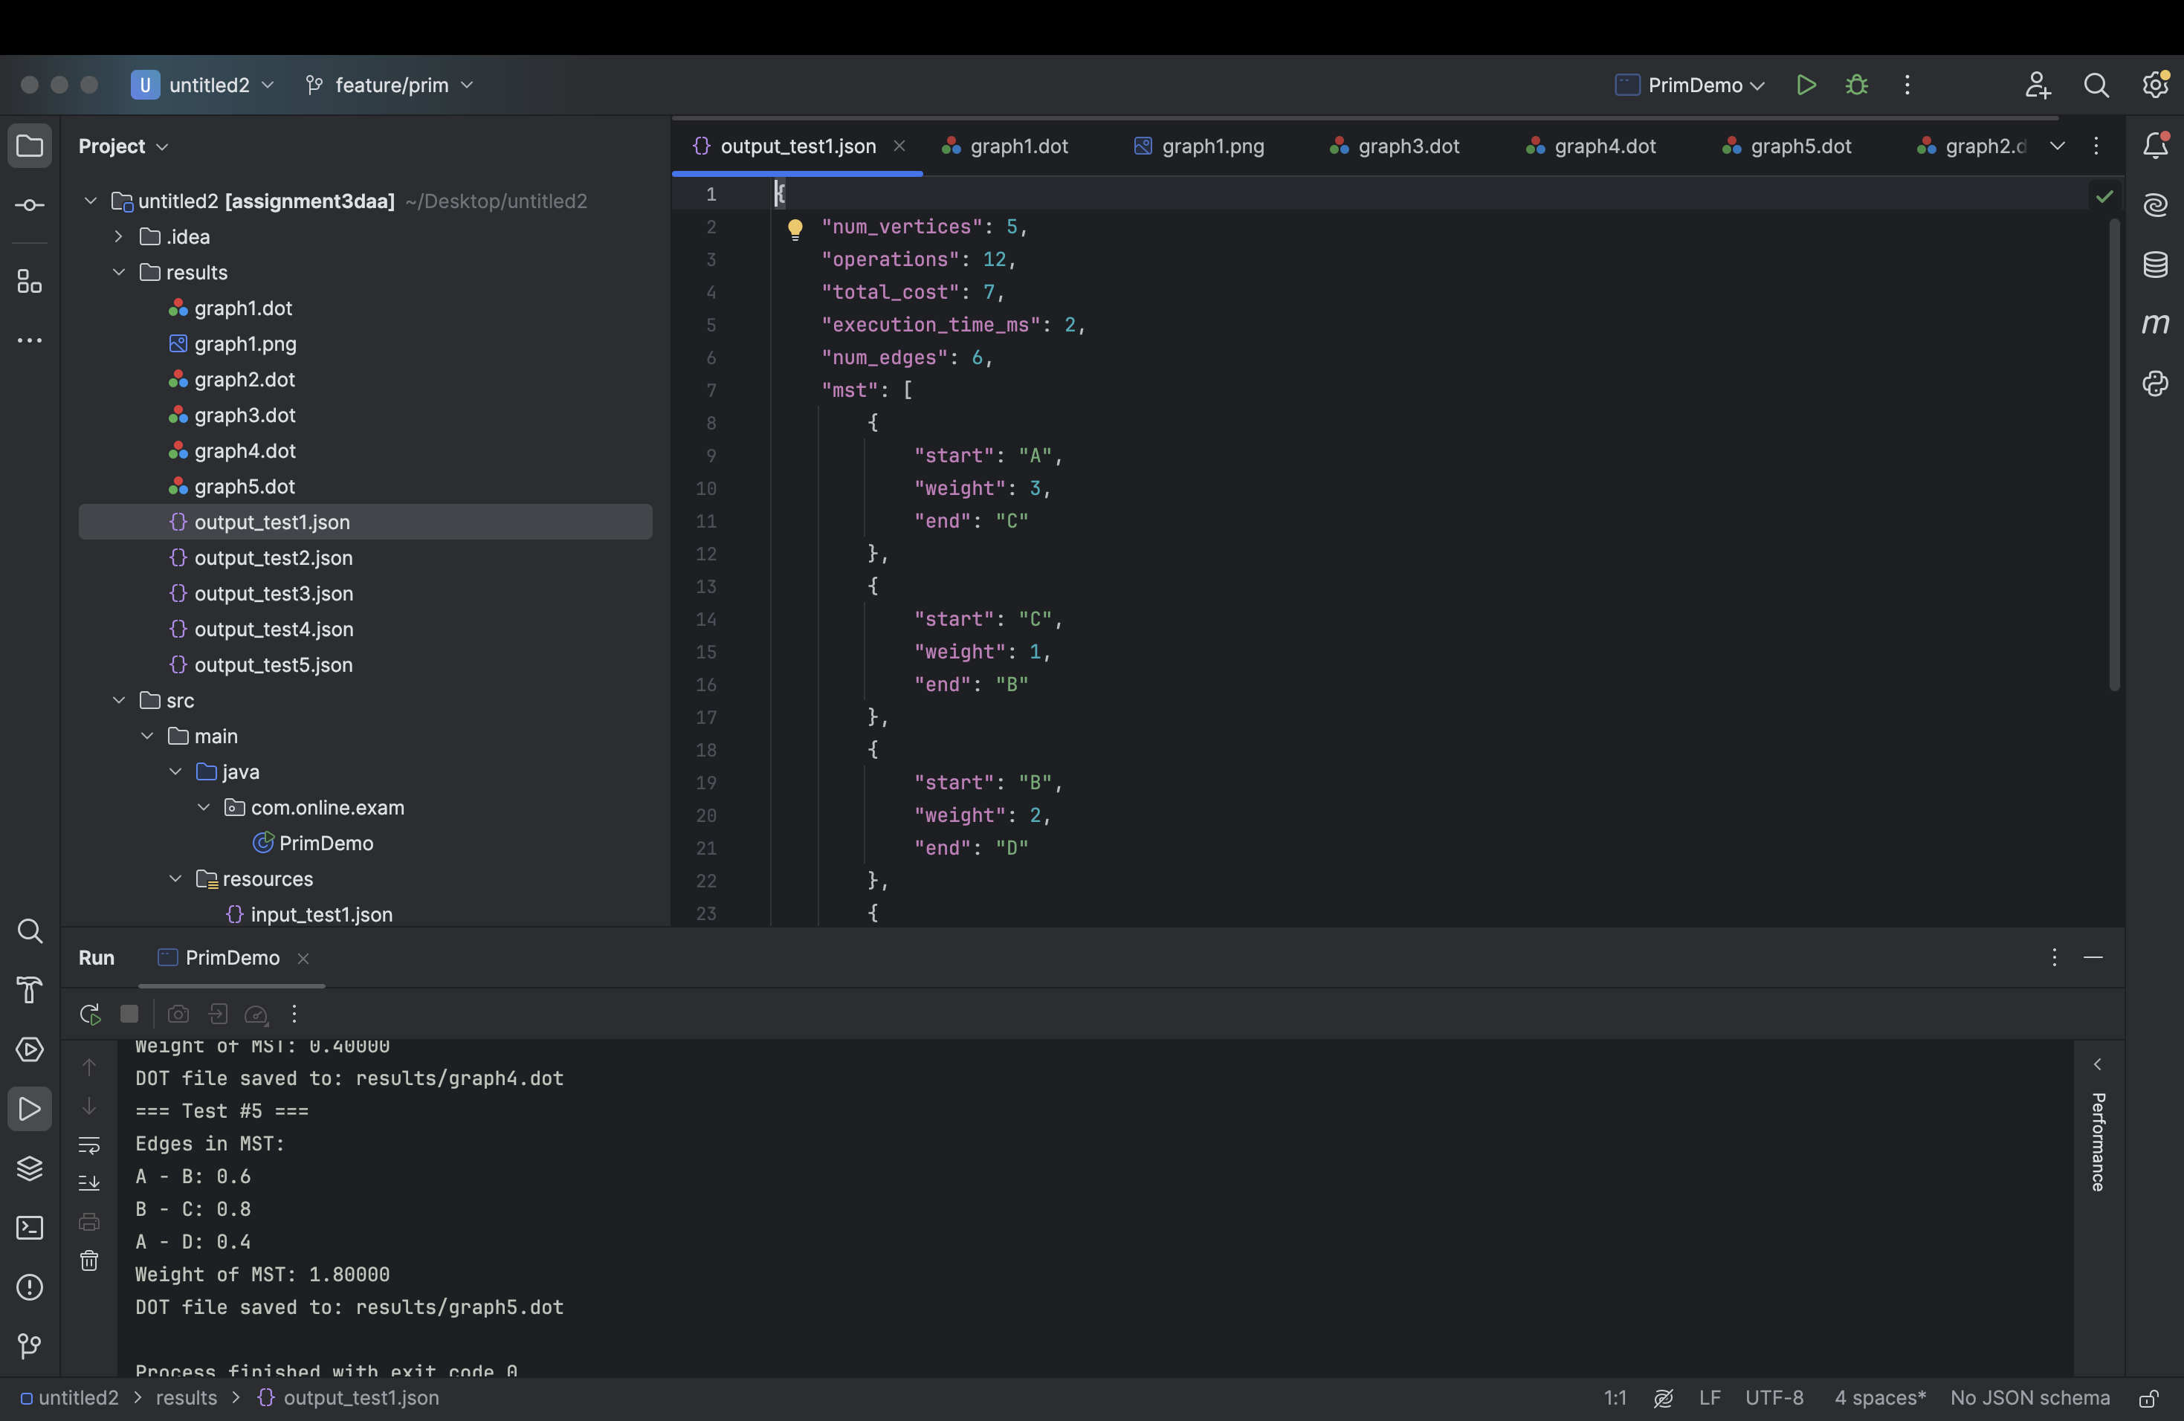

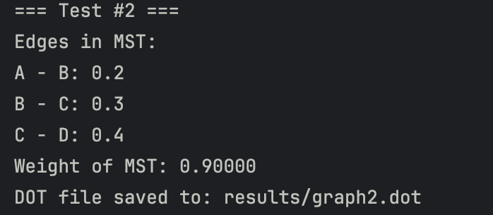

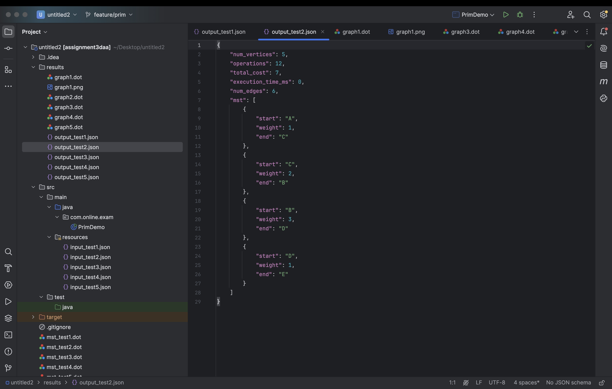

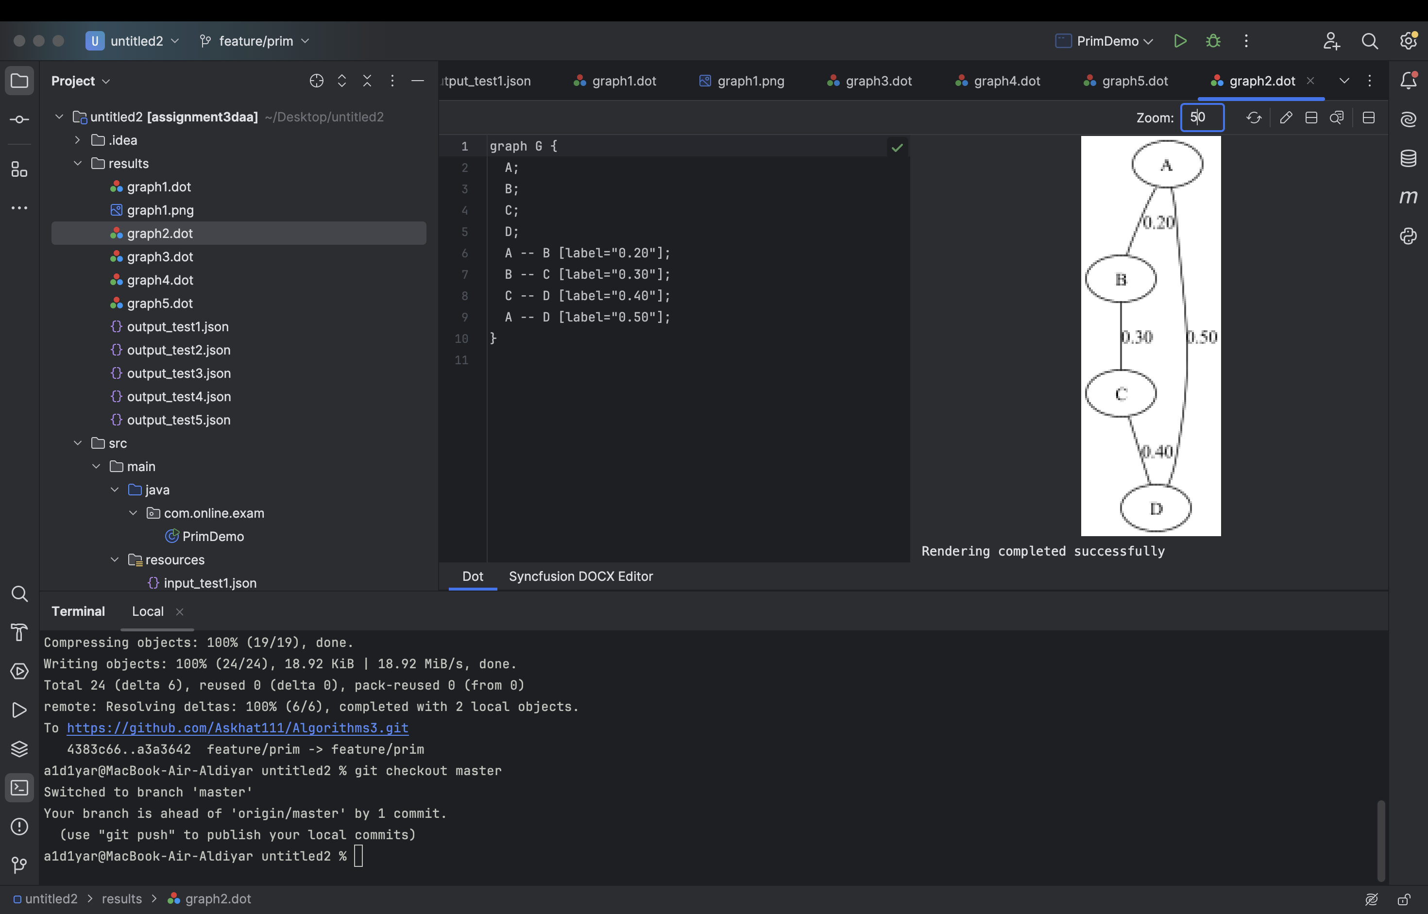

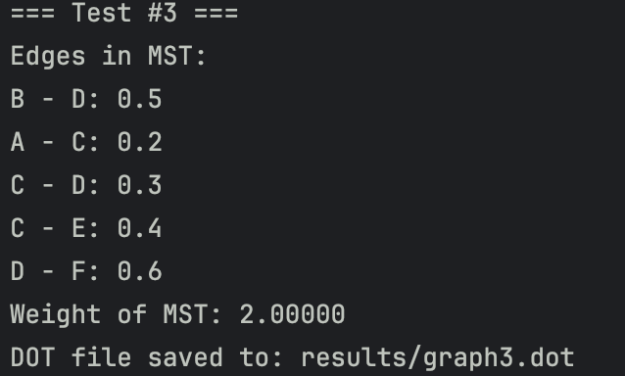

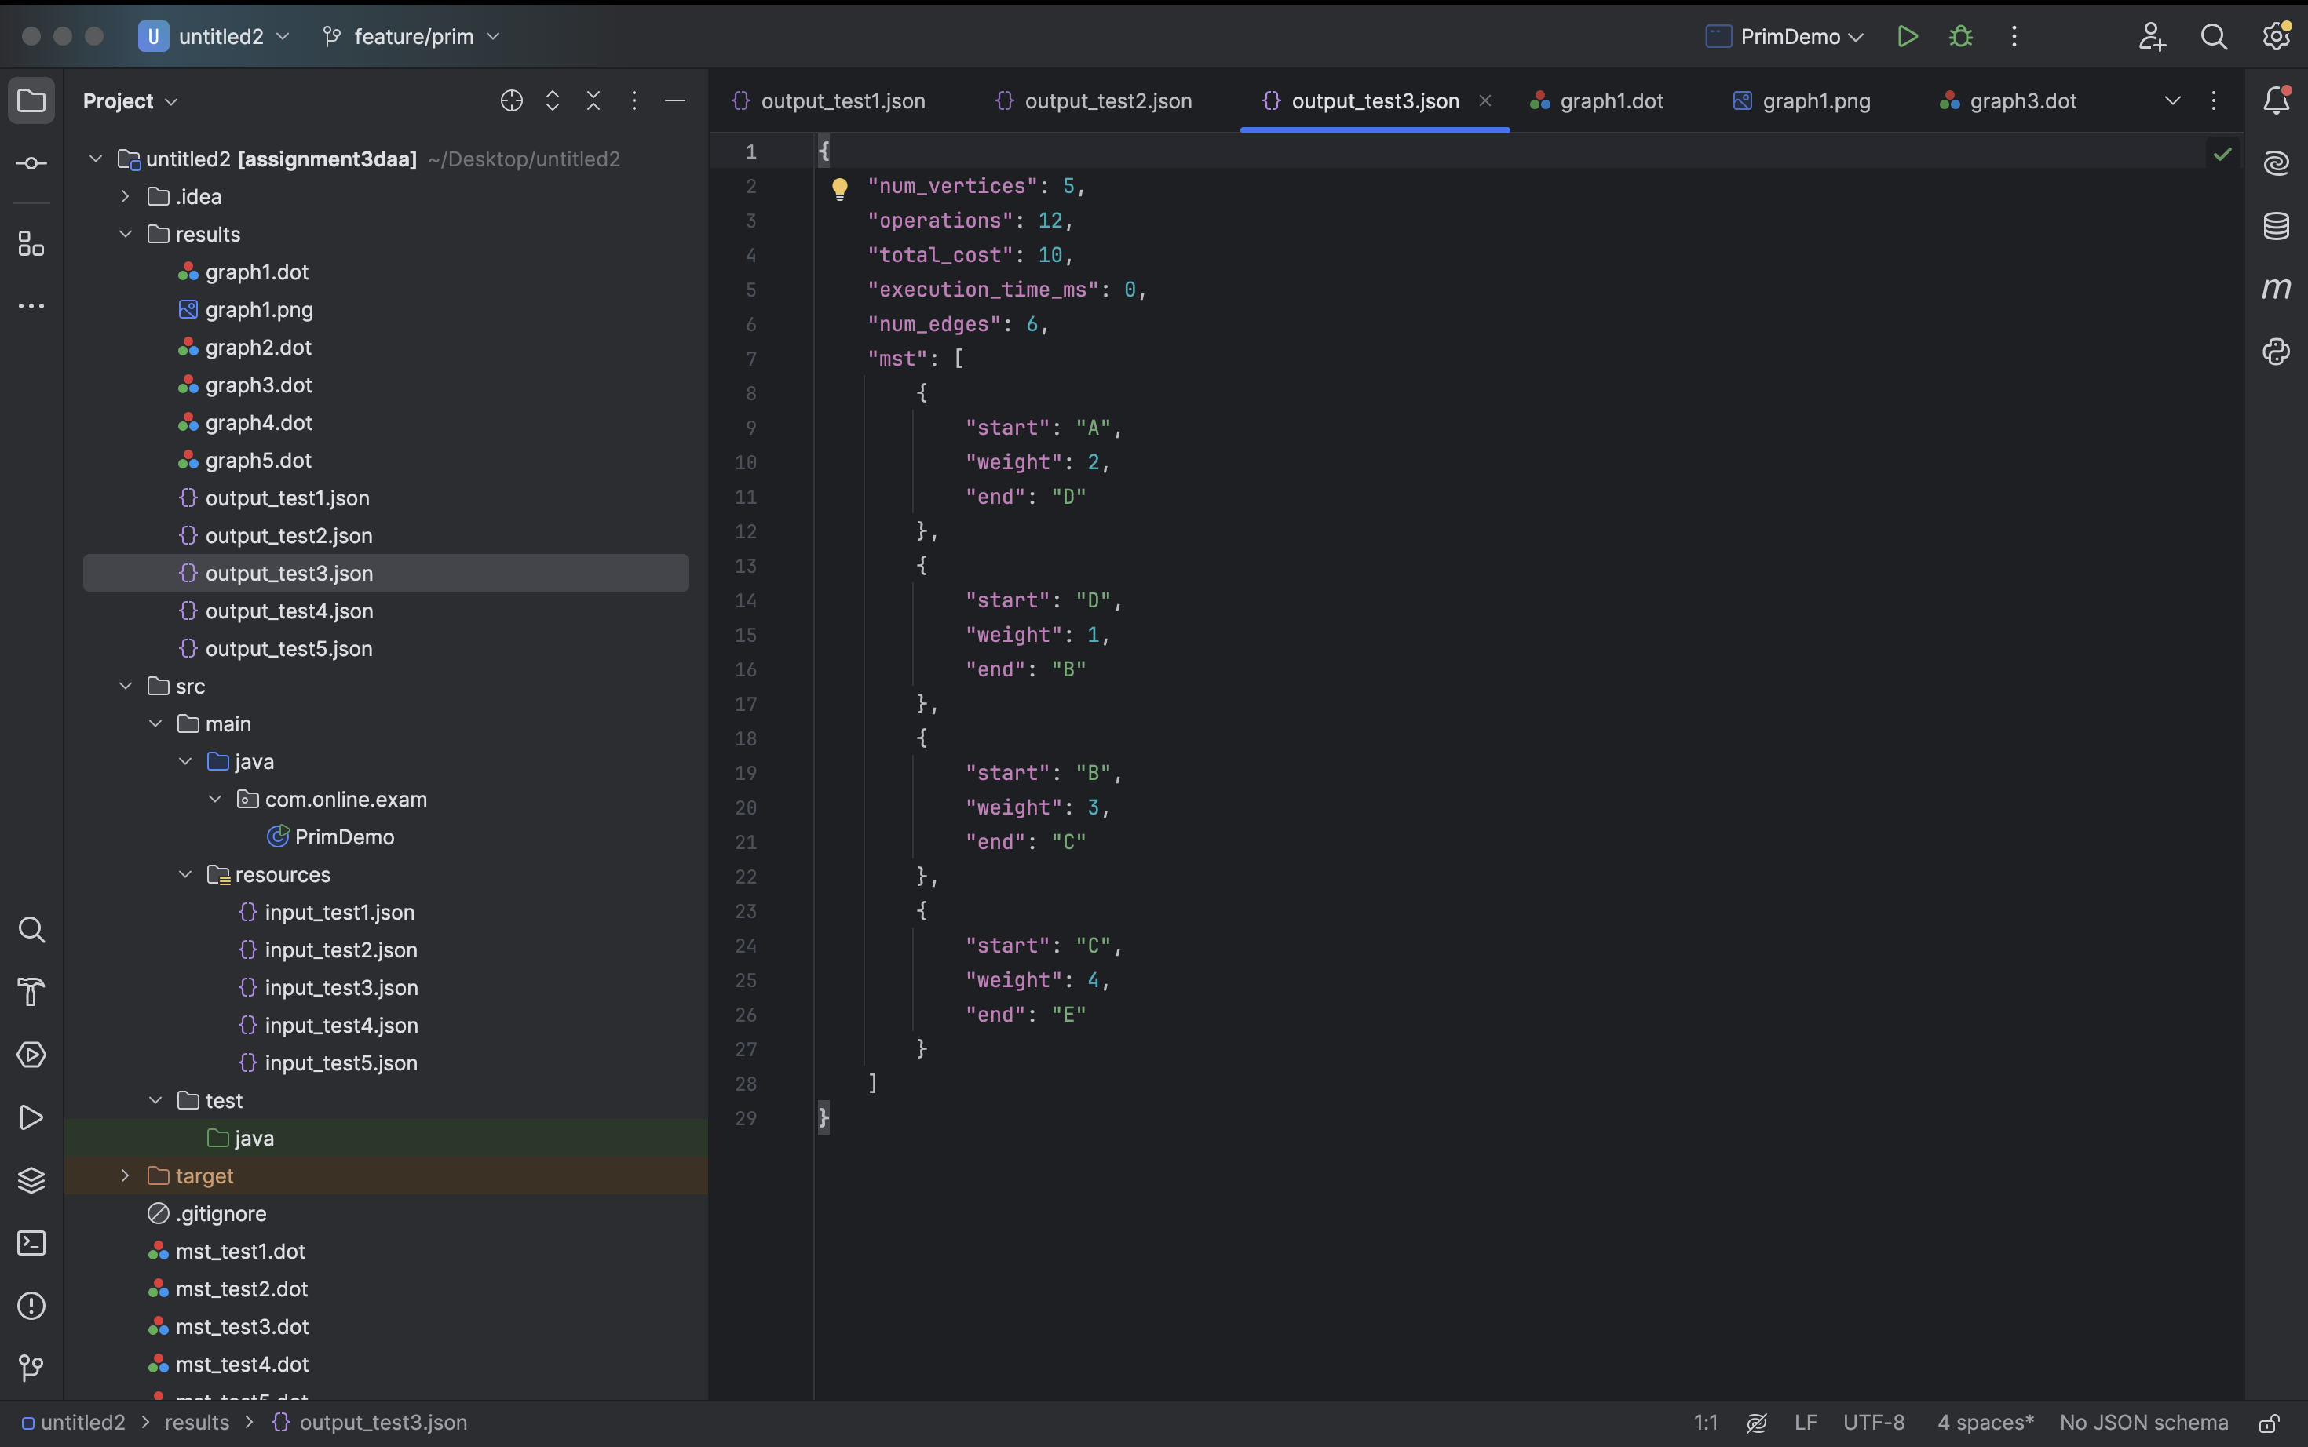

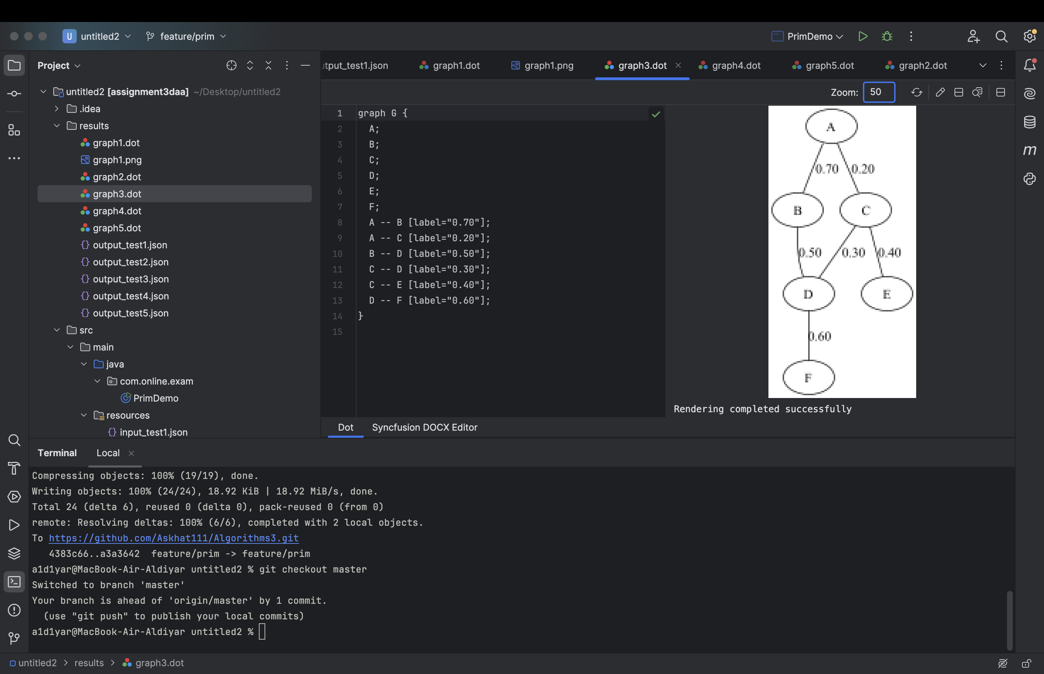

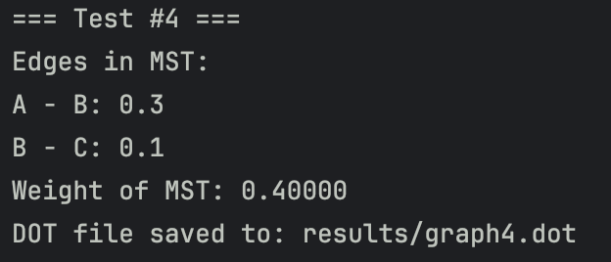

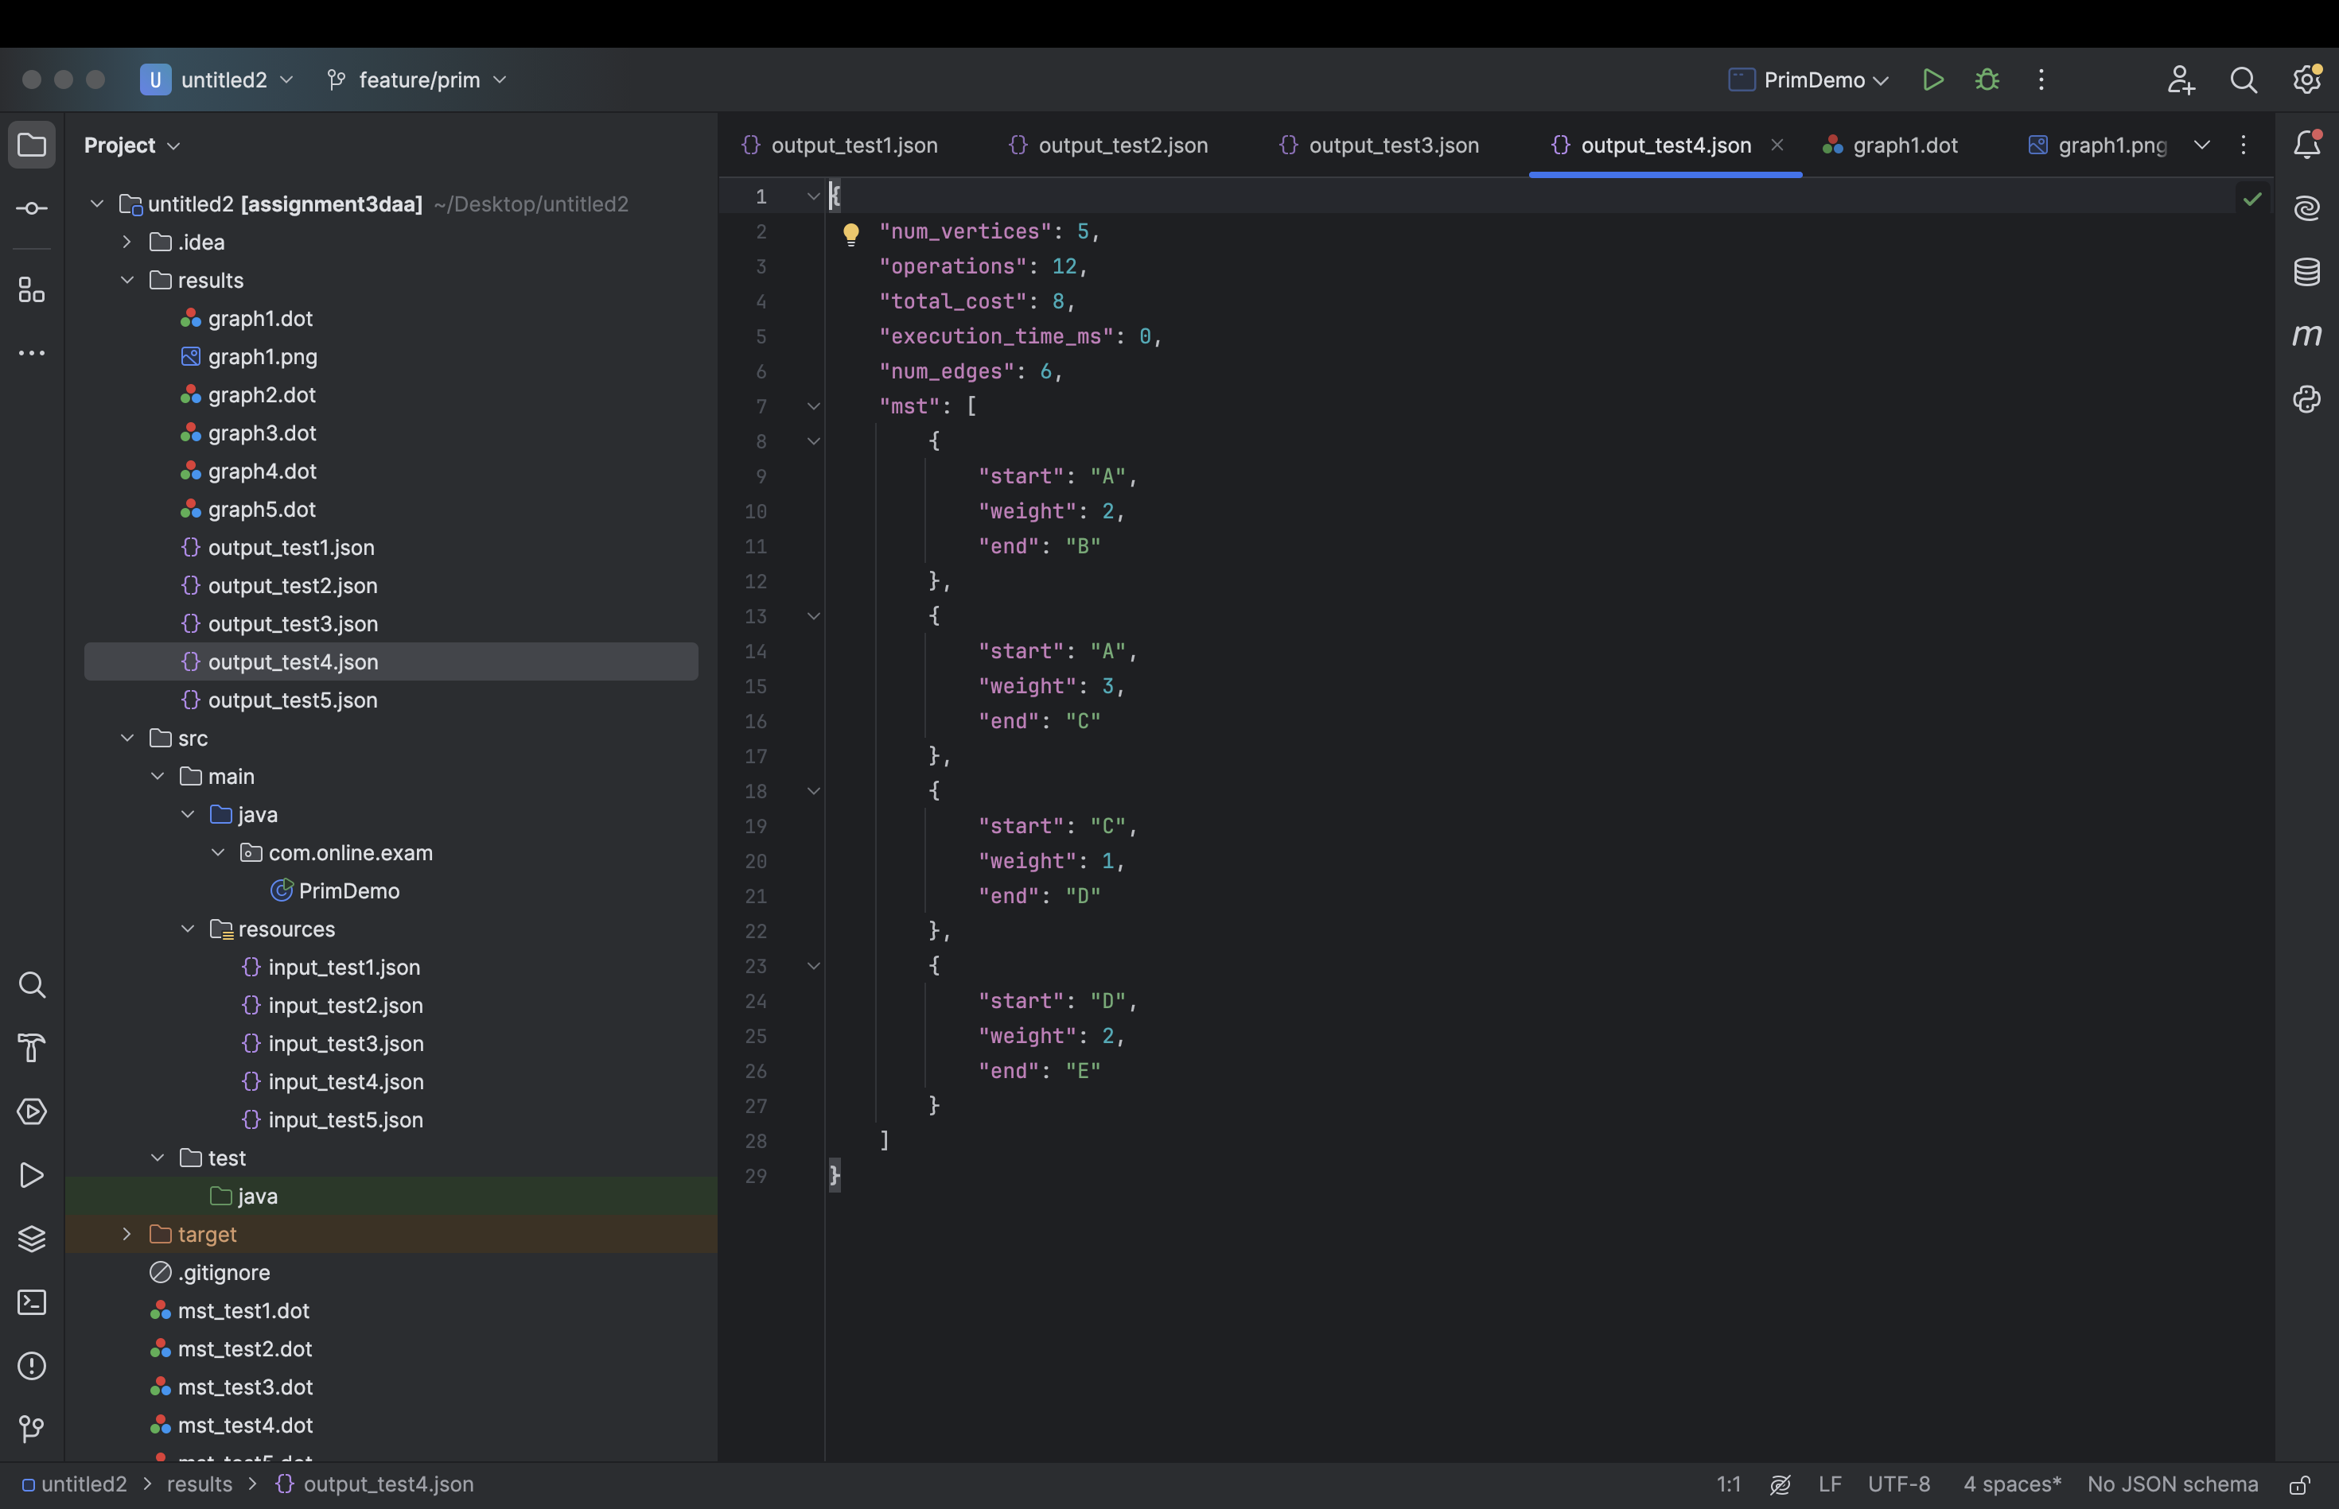

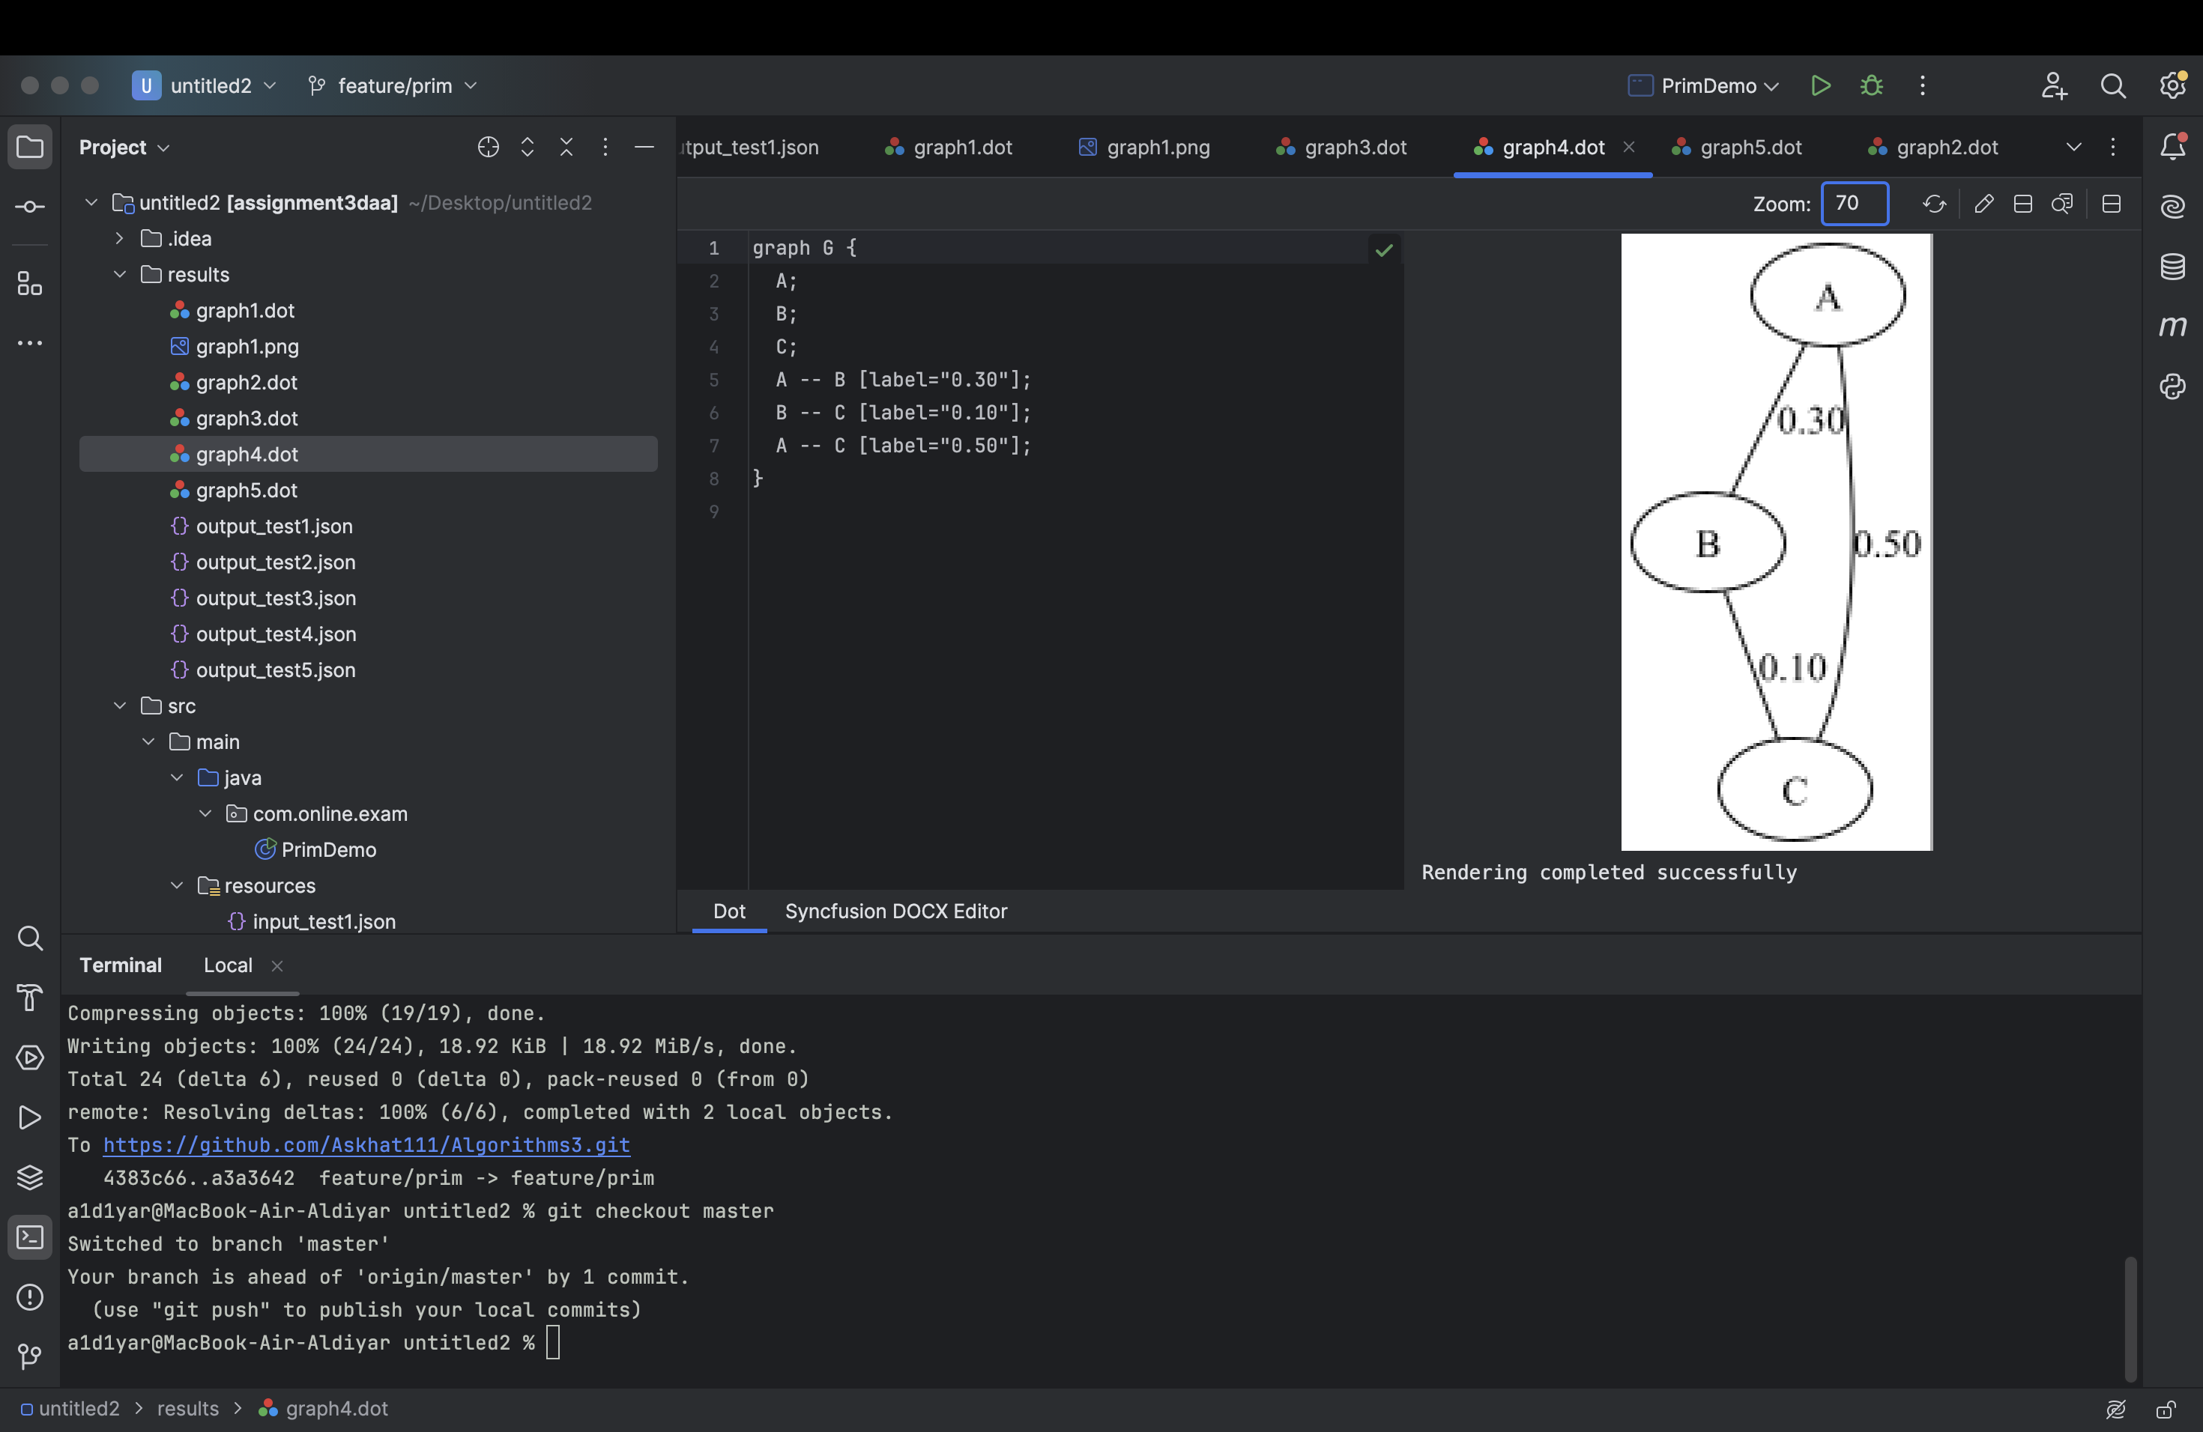

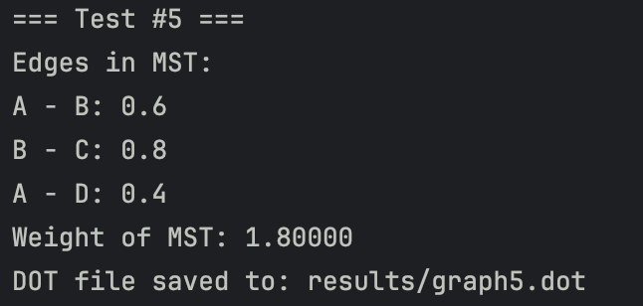

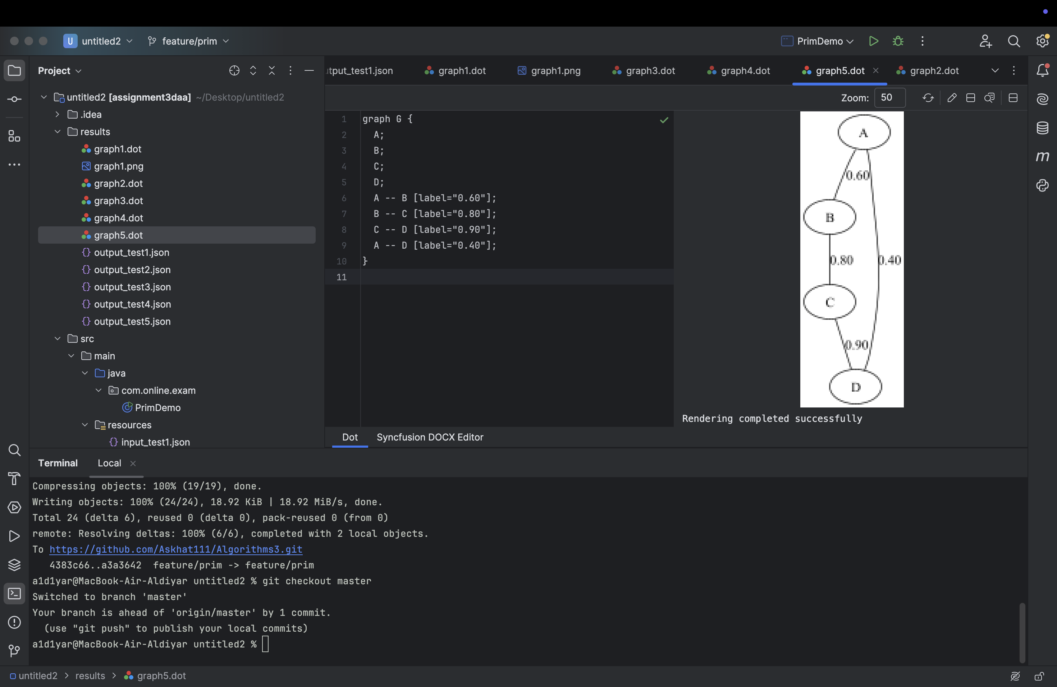

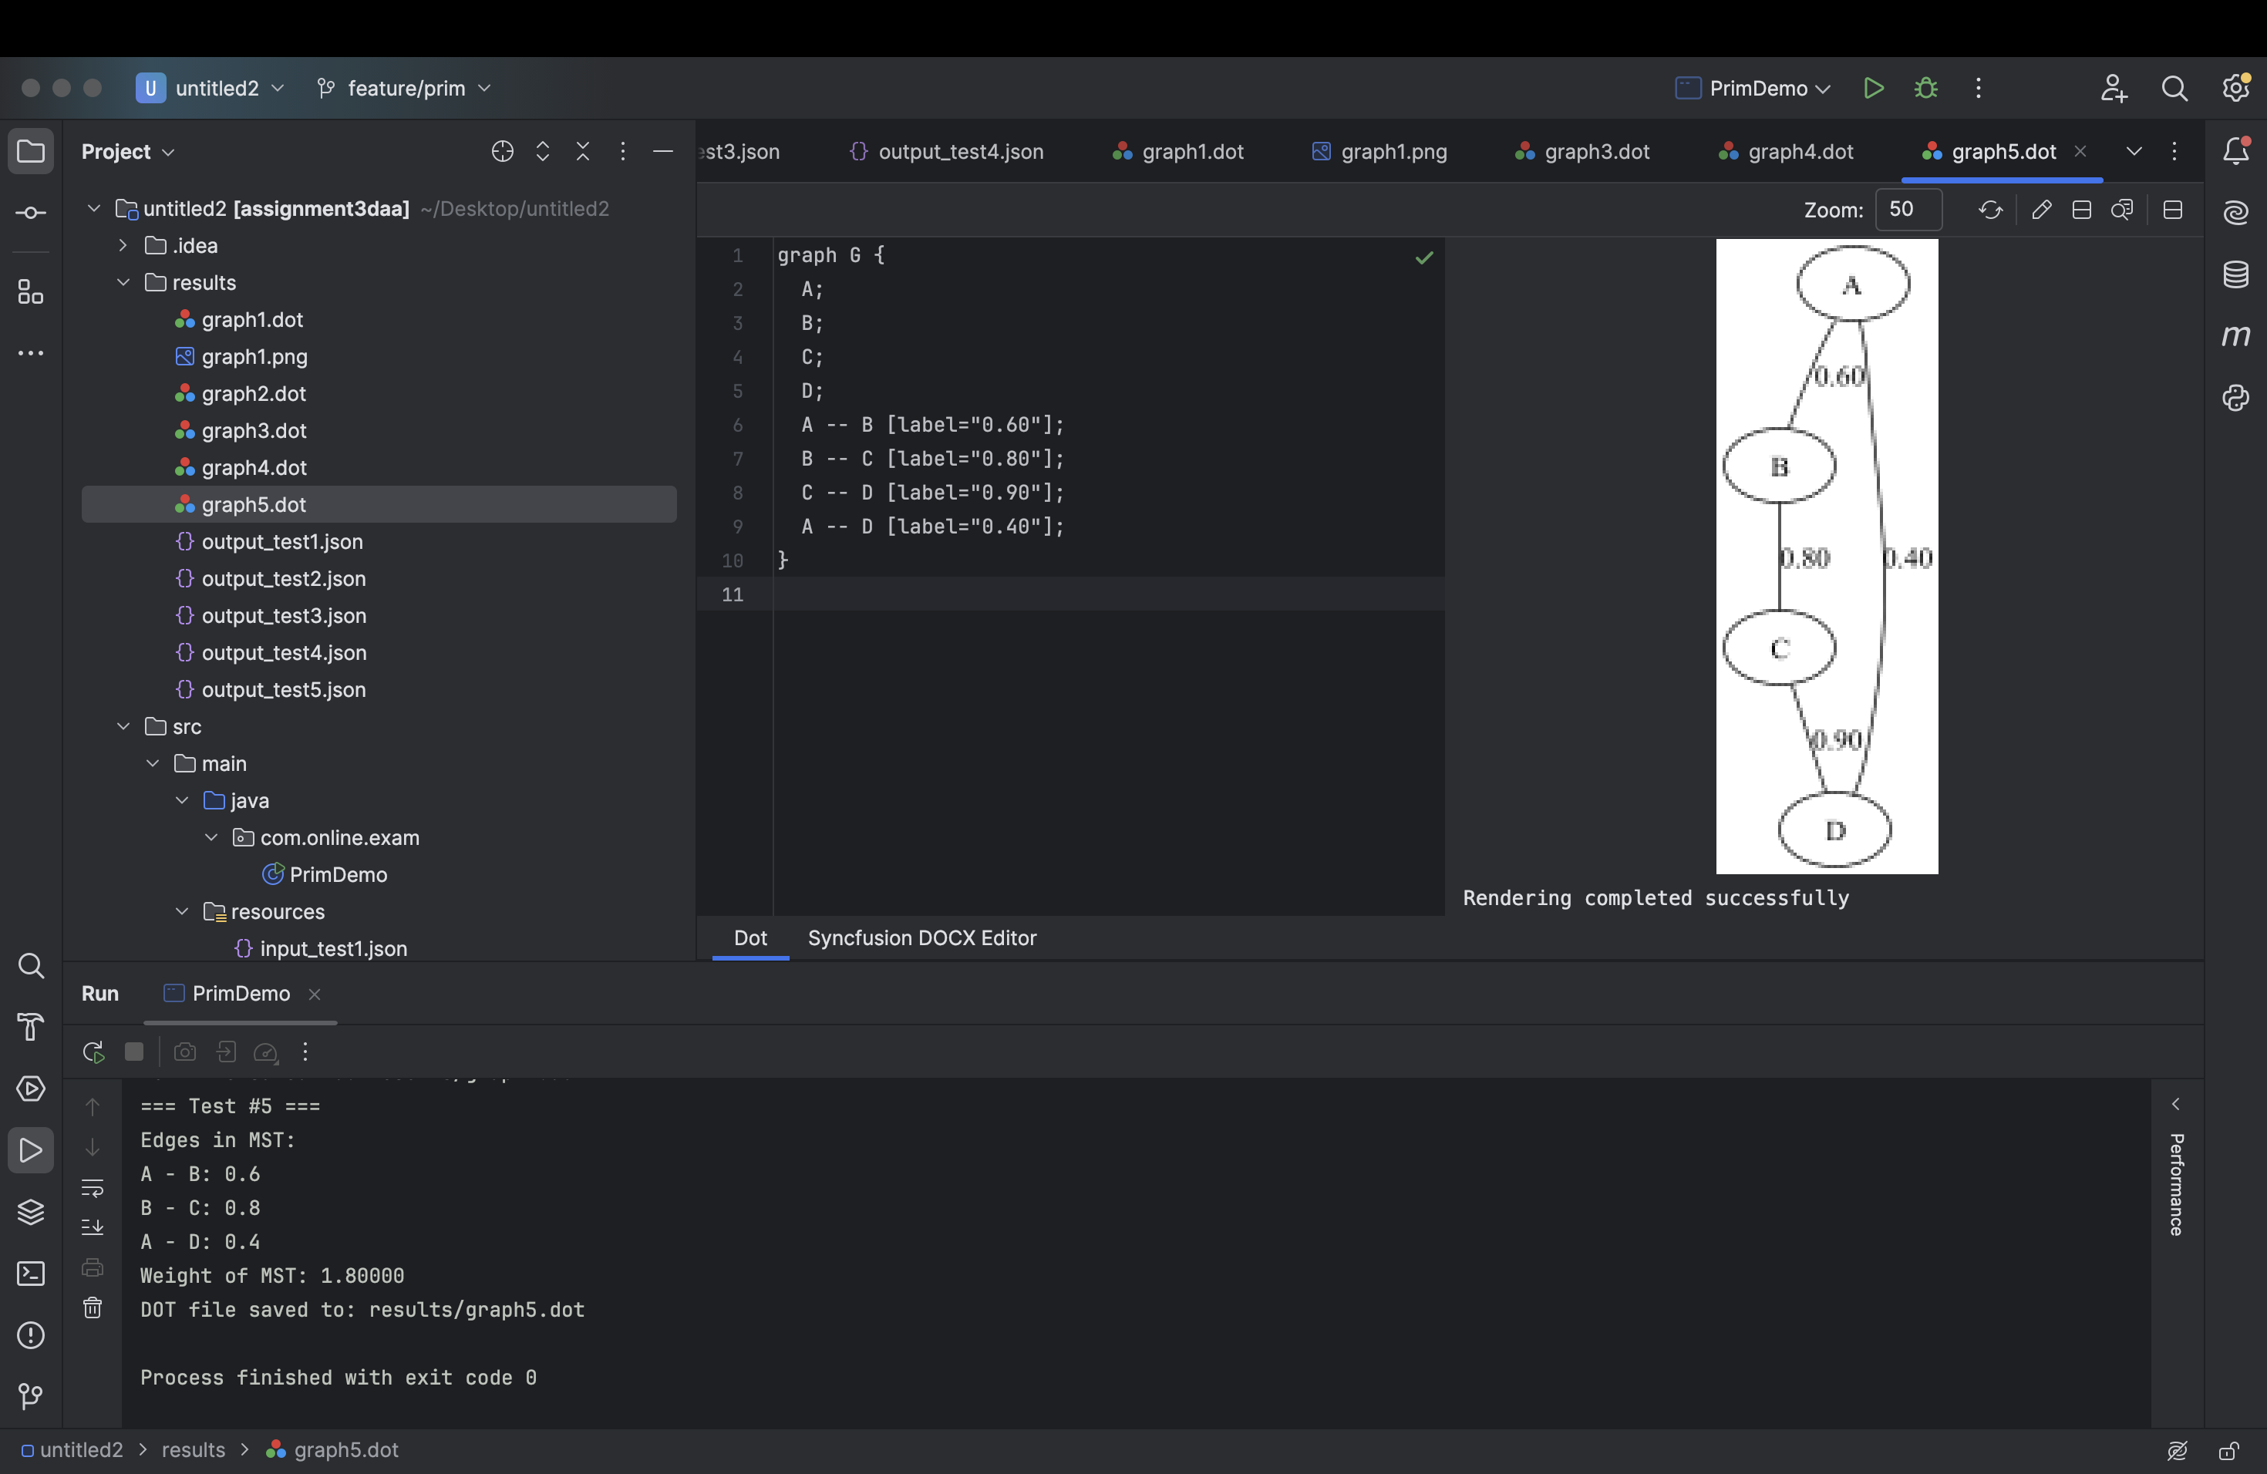

Kruksal:





























Comparison of Prim’s and Kruskal’s Algorithms

Both algorithms produced MSTs with identical total costs for all test cases, confirming correctness. Differences were observed in operational counts and runtime, depending largely on graph structure:

1)Kruskal’s algorithm is generally more efficient for sparse graphs, relying on sorted edge lists and union-find data structures.

2)Prim’s algorithm performs well on dense graphs with adjacency matrix or list representations, updating minimum edges efficiently.

Implementation complexity is somewhat higher for Kruskal’s due to union-find, but conceptually simpler with an edge-centric approach.

**Conclusions**

Both Prim’s and Kruskal’s algorithms are effective for MST problems in city transportation network optimization.Kruskal’s is effective for sparse graphs or when edges are naturally listed, Prim’s for dense graphs or adjacency representations.

Performance is competitive, algorithm choice may depend on graph input formats and specific application constraints.

Source:

<https://www.geeksforgeeks.org/dsa/kruskals-minimum-spanning-tree-algorithm-greedy-algo-2/>

**GitHub Link**

The code on Github :<https://github.com/Askhat111/Algorithms3>